

*Sunday*

*May 1,**2016*

*10 am - 5 pm*

*Bringing Back*

*the*



*Companion event*

Native *Plant Sale Extravaganza*

*Saturday and Sunday April 30 and May 1*

***ati****/I****ves***

*Garden**Tour*

*A free, self-guided tour of 30 Alameda and Contra Costa county gardens*

This delightful collection of native plant gardens ranges from *Al* Kyte's 40-year-old wildlife oasis to brand new installations, from large lots in the hills to small front-yard gardens, from local native plants to natives from throughout California, and from gardens designed and installed by owners to those designed and installed by professionals.

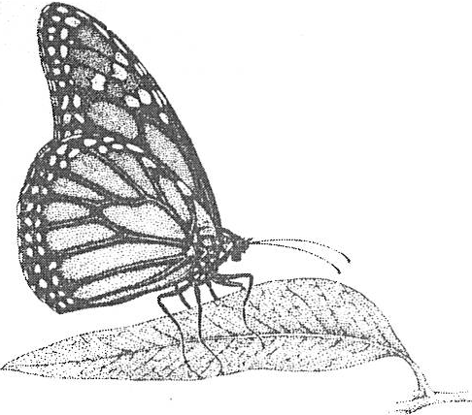

Free!

* Passes to 30 gardens
* Garden Guide that provides details on each garden
* Garden talks scheduled throughout the day

Learn how to:

* Select and care for California native plants
* Attract butterflies, birds and bees to your garden
* Garden without pesticides (and protect your children and pets!)
* Lower your water bill

www.BringingBackTheNatives.net