

**Need a Job?**

We offer a Job Training and

Placement Program that includes

12 weeks of training (full-time) in **computer skills** and career development, followed by **paid work** experience and assistance in finding a job in an **office environment.**

|  |  |
| --- | --- |
| **May 5th, 12th, 19th** | **May 8th** |
| Opportunity Junction  3102 Delta Fair Blvd.  Antioch, CA 94509 | Bay Point Career Center  Ambrose Community Center  3105 Willow Pass Rd.  Bay Point, CA 94565 |

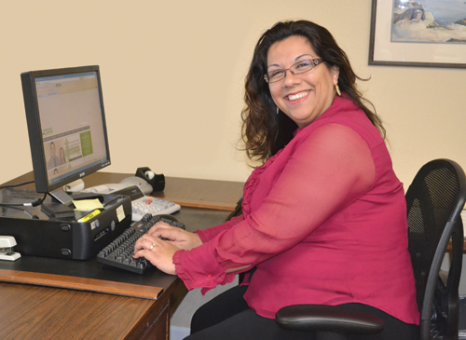

*At No Cost to Participants!*

*“I can take care of my kids without worrying about where the next meal is coming from.”*

**93% of our graduates get a job within 6 months of completing the program.**

*Government partners include the CDBG Programs of the City of Antioch, City of Pittsburg, and Contra Costa County; the Contra Costa County CSBG Program, and Contra Costa’s Employment and Human Services Department.*

*Must arrive by 10:00 AM  
No late admittance.*

*Must arrive by 9:45 AM  
and be prepared to stay up to two hours following orientation for an intake interview*

**For more information,**

call 925-776-1133, visit us at

OpportunityJunction.org/jtpp, or

attend an application session:

2012