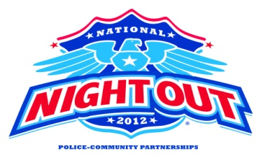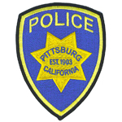

**PITTSBURG POLICE DEPARTMENT IS A PROUD SUPPORTER OF National Night Out, an annual event designed to strengthen our communities by encouraging neighborhoods to engage in stronger relationships with each other and with their local law enforcement partners. The goal is to heighten crime-prevention awareness, build support and participation in local anti-crime programs, and most importantly, send a message that our neighborhoods are organized and fighting back. It’s also the perfect opportunity to get to know your neighbors even better. We hope to see you there!**